Sweet Potato Bites

Submitted by: Katrina H.

*serving size: 6-8*

You will need:

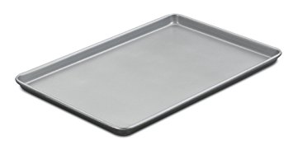   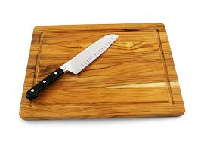

baking sheet potato peeler measuring spoons cutting board & knife

spoon

3-4 medium sized sweet potatoes, peeled



2 tbsp. melted butter

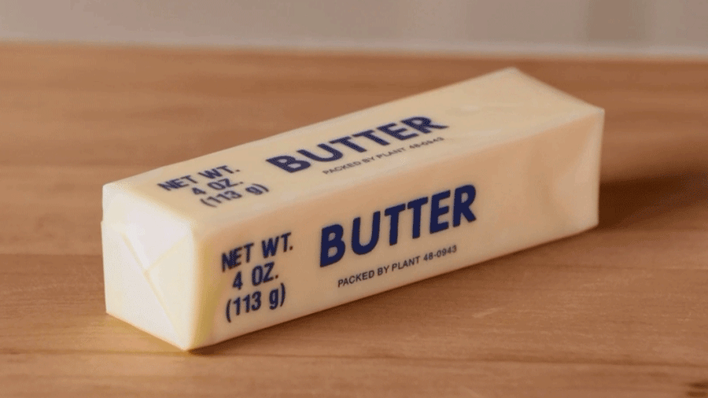

1 tsp. maple syrup

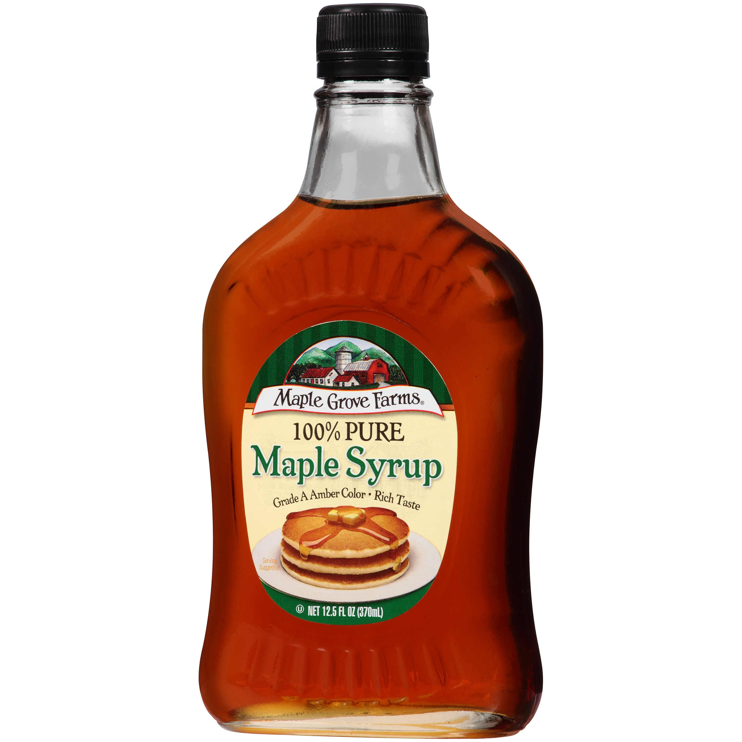

kosher salt



marsh-mallows



Directions

1. Preheat oven to 400 degrees.
2. Slice sweet potatoes into ¼” round pieces.
3. Toss potato slices in melted butter and maple syrup.
4. Place on an even layer on a baking sheet and bake for ~20 minutes or until tender, flipping the potatoes halfway through.
5. Remove the potatoes from the oven and top each slice with a marshmallow and broil in the oven until marshmallows are golden brown.
6. Top each slice with a pecan and enjoy!



Ingredients

pecan halves

